**SOVULO PTY LTD**

**Triton Trout Farm**

**POLLUTION INCIDENT RESPONSE MANAGEMENT PLAN**

**For *Triton Trout Farm [EPL 12180]***

Site view

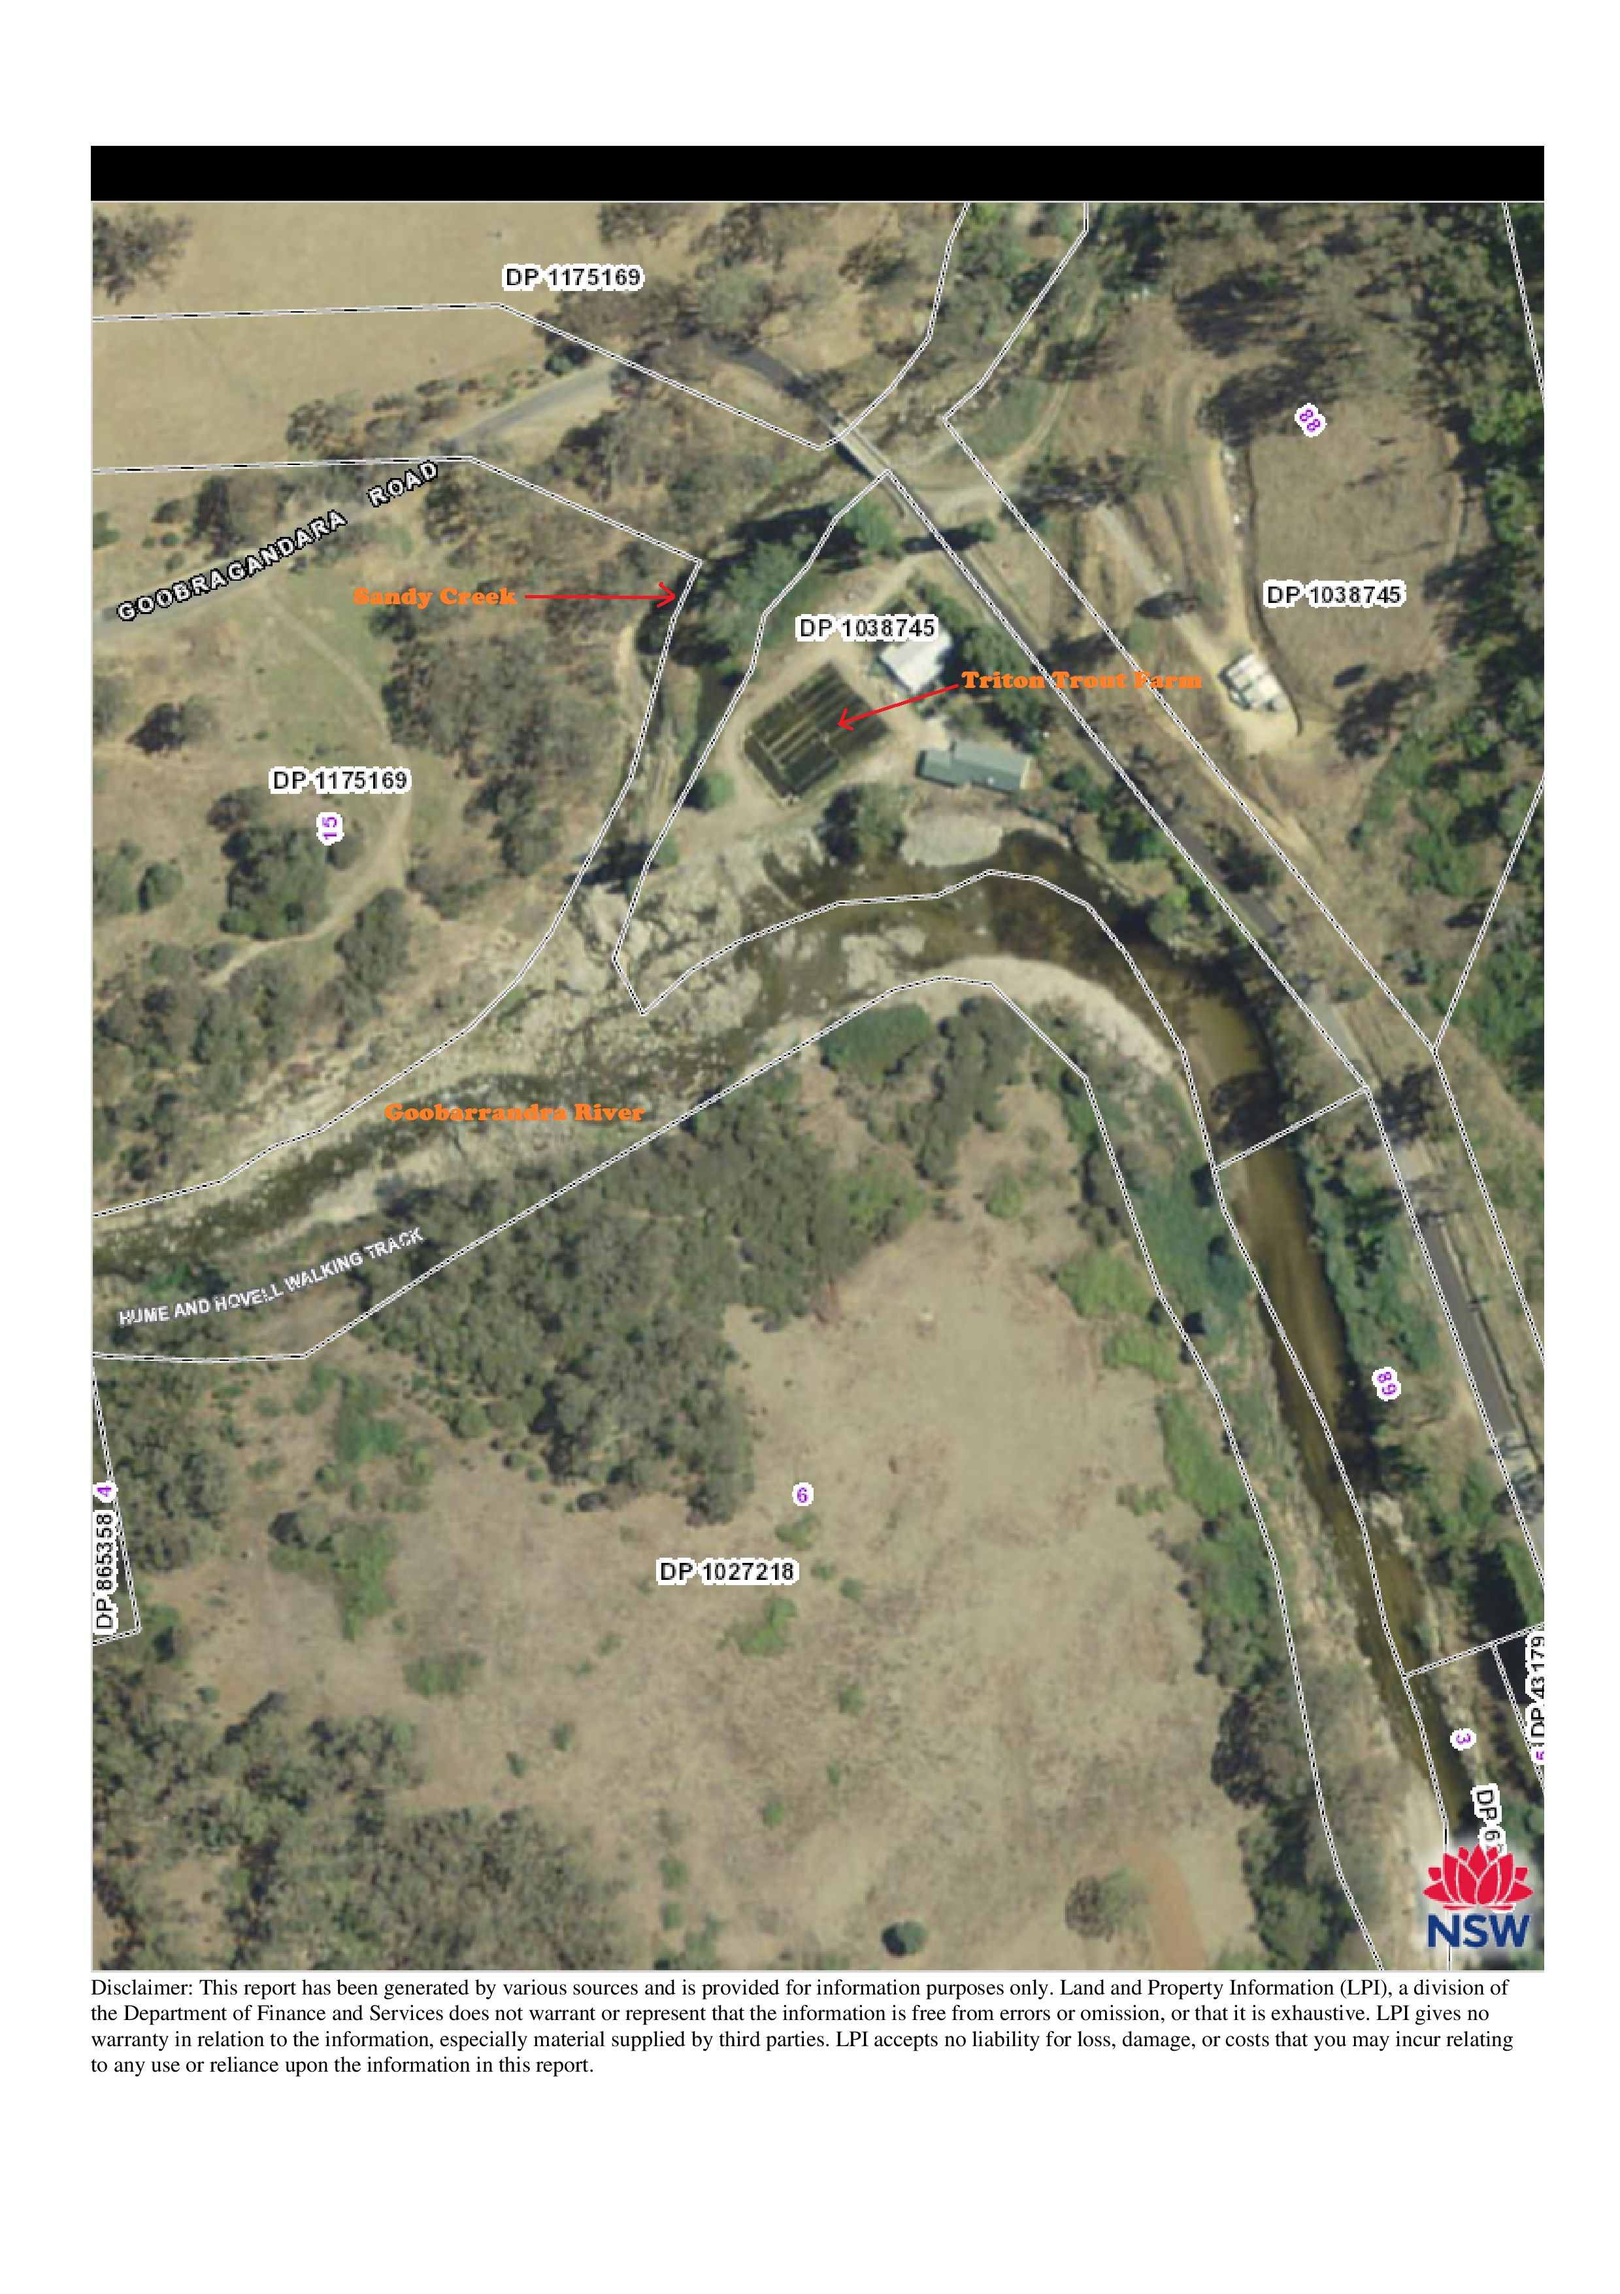

**Premises Location**

838 Goobarragandra River Road

Tumut NSW 2720

Map Co-ordinates

Map 55H

626941.55 East

6087756 North

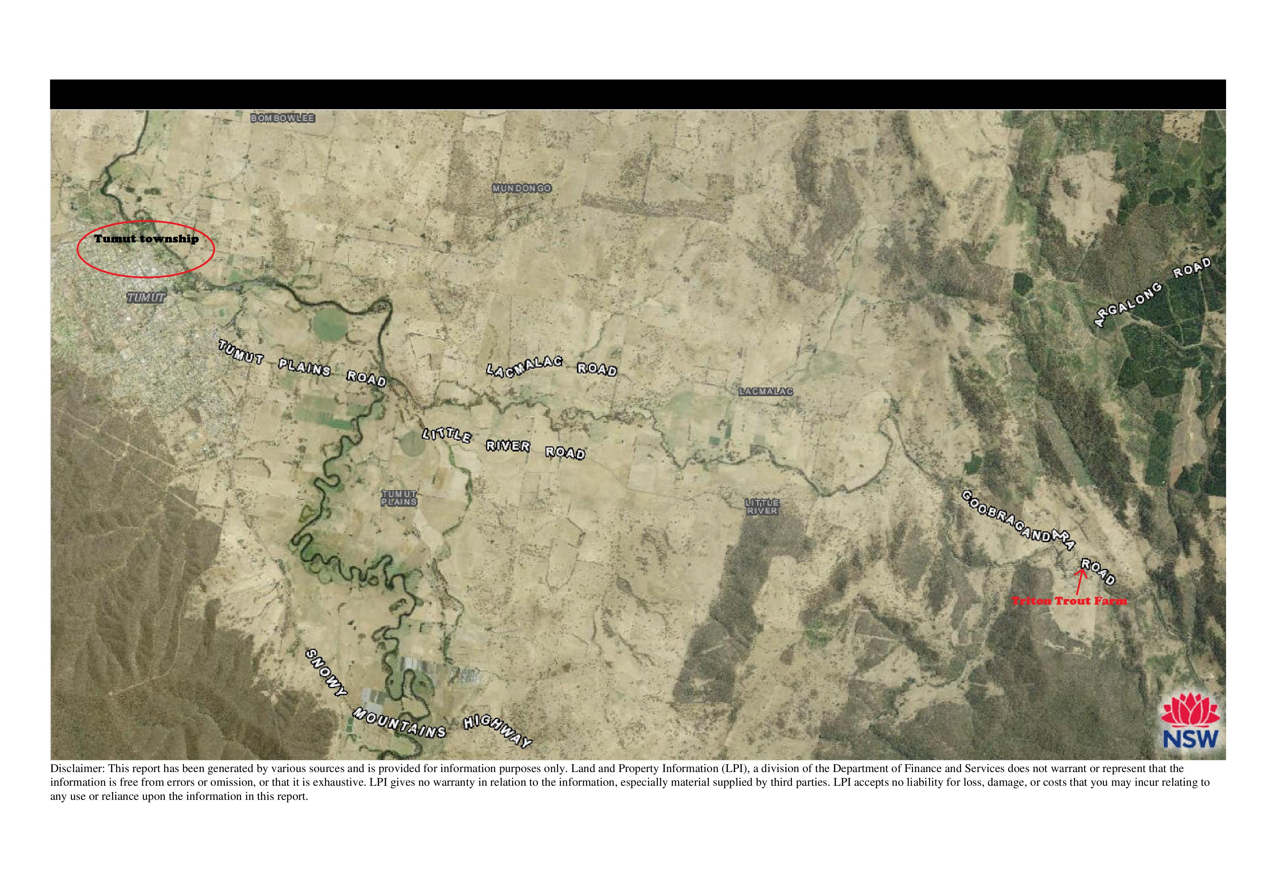

Sovulo Pty Ltd, Triton Trout facility location.

**Premises Location**

838 Goobarragandra River Road

Tumut NSW 2720

Map Co-ordinates

Map 55H

626941.55 East

6087756 North

**Contents**

|  |  |
| --- | --- |
| Site view of Triton Trout Farm | Page.2 |
| Location Site view of Triton Trout Farm | Page.3 |
| Overview of the PIRMP | Page.5 |
| Introduction | Page.5 |
| Purpose of the plan | Page.5 |
| Scope of the plan | Page.6 |
| Responsibilities of staff and Management | Page.6 |
| Documentation | Page.7 |
| Emergency contact listings | page.7 |

HAZARD, LIKELIHOOD AND PRE-EMPTIVE ACTIONS TO PREVENT   
POLLUTION INCIDENT RISKS

|  |  |
| --- | --- |
| overview | Page.8 |
| Pre-emptive measures to be taken to prevent/minimise any pollution event | Page.8 |
| Summary of pollution types | Page.9 |
| Main Pollutant Liabilities at Triton Trout Farm | Page.9 |
| Pollutant materials at Triton Trout Farm | Page.10 |
| Hazard identification & risk analysis | Page.11 |
| Pollution incident actions & responses | Page.13 |
| Pollution incident record details | Page.14 |
| Staff training details | Page.15 |
| Staff training attendance record | Page.17 |
| Testing of plan | Page.18 |
| Plan Commencement date | Page.18 |
| PIRMP test &amendment record sheet | Page 19 |
| Definitions | Page.20 |

1. **OVERVIEW**

This Pollution Incident Response Management Plan (PIRMP or Plan) has been written to comply with

the legislative requirements under the *Protection of the Environment Operations Act 1997* (POEO

Act) and the *Protection of the Environment Operations (General) Regulation 2009.*

This plan has been prepared by Frank Robinson, Environmental Advice ABN **98 311 268 058** to comply with Sovulo Pty Ltd (the Licensee) obligations under the POEOA Act for Licence number 12180, Triton Trout Farm, 838 Goobarragandra River Road

.

Under the legislation referred to above, the EPL also requires a PIRMP to clearly document pollution risks, communication procedures to authorities and community regarding pollution incidents, and testing and training for pollution response. If there is a pollution incident involving material harm or threatened material harm to human health or the environment, the PIRMP will be implemented.

The PIRMP contains the following sections as required by the regulation:

**Introduction**

Triton Trout Farm is licensed to Sovulo Pty Ltd of 838 Goobarragandra River Road Tumut NSW 2720.

This site is covered by an Environment Protection Licence (EPL) 12180 for scheduled activity of Aquaculture & Mariculture.

Pollution Incident Response Management Plan (PIRMP) preparation is a requirement for holders of Environment Protection Licences (EPLs). Triton Trout farm operates under EPL no. 12180 and is therefore required to prepare a PIRMP and implement the PIRMP if and when an incident occurs.

**Purpose**

The purpose of this PIRMP is to improve the way pollution incidents are reported, managed and communicated to the general community.

The purpose of this plan is to:

Ensure comprehensive and timely communication about a pollution incident to staff at the premises, the Environment Protection Authority (EPA), other relevant authorities specified in the Act (such as local councils, NSW Ministry of Health, WorkCover NSW, Fire and Rescue NSW, Rural Fire Service NSW and Department of Primary Industries NSW and the New South Wales Office of Water) and people outside the facility who may be affected by the impacts of the pollution incident

Minimise and control the risk of a pollution incident at the facility by requiring identification of risks and the development of planned actions to minimise and manage those risks

Ensure that the plan is properly implemented by trained staff, identifying persons responsible for implementing it, and ensuring that the plan is regularly tested for accuracy, currency and suitability.

**Scope**

This PIRMP is for the use of all Triton Trout Farm staff involved in the day to day management, handling and controlling of all Trout Facility operations including such activities as Water supply and discharge qualities and quantities, cleaning of the premises, control of pest species care and movement of fish, fry & fingerlings receival and storage of feedstock’s, repair and maintenance of plant and equipment and health and safety of all employees and surrounding property occupants and any contractors undertaking works on the site. The PIRMP will be implemented only if material harm in accordance with the description contained in the Protection of the Environment Operations Act to human health or the environment occurs or threatens to occur. (see definitions at Page 20)

The Triton Trout Farm site is located at the confluence of the Sandy Creek and the Goobarragandra River and 16.5 Kilometres ESE of the town of Tumut at 838 Goobarragandra River Road,Road.

Environmental Management at the site is subject to improvements in processes and practices from time to time. To accommodate these ongoing changes and also to accommodate increases in site specific environmental assessment and management, the plan will be progressively reviewed.

This Plan is to clearly define the requirements of Triton Trout Farm staff to report and respond to pollution incidents in accordance with section 153F of the POEO Act 1997 and the POEO (General) Regulation 2010

**Responsibilities**

All Triton Trout Farm staff and contractors are responsible for understanding and implementing this PIRMP as appropriately identified. The PIRMP identifies the general roles and responsibilities of how Triton Trout Farm staff shall manage pollution incidents in accordance with this PIRMP.

The owner and Supervisors are responsible for ensuring that their staff are aware of the PIRMP and their roles where appropriate. All Management are also responsible for the training of their staff and hold responsibility for:

1. assisting with advice, reporting and response process;
2. ensuring the Plan is made available to staff responsible for implementing the plan and EPA authorised officers;
3. giving advice on whether environmental incidents need to be reported to external agencies;
4. assisting in the notification of pollution incidents to the relevant authorities
5. provision of maps associated with the plan
6. assistance with the implementation of response actions to pollution incidents
7. assistance in communicating with neighbours and the local community about the Plan and

when incidents of a reportable nature occur;

1. testing; and
2. Reviewing this plan

**Documentation**

The environmental incident register is used to record and monitor all environmental incidents within the Triton Trout Farm facility. The register will assist with record keeping, reporting and determining improvements to incident response and review of the Plan. The register is kept by the Facility Manager, Ewan Watkins.

**Additional Information**

Contact: Ewan Watkins 0429 874 866

|  |  |  |
| --- | --- | --- |
| Effective date: | 31st January 2015 |  |
|  |  |  |
| Review date: | See Updating of Plan |  |

**Emergency contact details**

|  |  |  |  |
| --- | --- | --- | --- |
| Ewan Watkins | General Manager/Owner operator | 0429 874 866 |  |
| Rural Fire Service |  | 000 |  |
| Fire & Rescue NSW |  | 000 |  |
| Ambulance |  | 000 |  |
| Tumut Shire Council |  | 02 6941 2555 |  |
| |  |  | | --- | --- | | Emergency Animal Disease Hotline |  | |  | 1800 675 888 |  |
| Workcover NSW |  | 131050 |  |
| Environment Protection Authority (EPA) |  | 131555 |  |
| NSW Health Department |  | 02 9391 9000 |  |
| Fisheries NSW |  | 02 6391 3100 |  |
| NSW Office of Water |  | (02) 8281 7777 |  |

**HAZARD, LIKELIHOOD AND PRE-EMPTIVE ACTIONS TO PREVENT**

**POLLUTION INCIDENT RISKS**

**Overview**

This chapter deals with the POEO (General) Regulation 2009’s sections 98(a) to 98(f) and partially

covers s98(j). These sections deal with the hazard, likelihood and pre-emptive actions which are similar processes to undertaking a risk assessment and providing appropriate control measures to prevent or minimise these risks.

The Triton Trout Farm site undertakes the commercial production and sale of unprocessed Fish (trout).

This Plan also considers both air and water based pollution incident impacts. Overall considerable design and written environmental management systems are in place to effectively minimise the likelihood and impact of a pollution incident. However, such incidents despite the best design and management methods can occur. Such accidental events are also covered in the Plan by the use of incident response methods.

This Plan uses a modular approach to this risk assessment process. Each module represents an operation undertaken in the farming operation such as use and storage of hazardous chemicals and use and storage of non-hazardous chemicals, the storage and handling of feedstock’s, the handling and use of input materials such as Feed and inoculants.

**Pre-emptive measures to be taken to prevent/minimise any pollution event**

1. Not less than weekly inspections of the water systems are to be carried out by the Facility Manager or their deputy. These inspections are to be recorded together with the associated observations in a record kept for the purposes.
2. Not less than 2 times per week the water return system to the Sandy Creek within the facility is to be inspected. These inspections are to be record together with the associated observations in a record kept for the purposes.
3. All plant and equipment is to be maintained in proper and efficient working order.
4. All safety equipment, fire fighting equipment, is to be maintained and tested on a regular basis.
5. All fire fighting equipment is to be tested not less than one month prior to the commencement of the declared fire season for the Tumut Shire Council area.
6. Farming is to be dealt with in accordance with best practice procedures.

Actions arising from these inspections are to be recorded in the record. Actions may be problem with over feeding of fish stock and potential high nutrient loaded discharge water held on site?

**Summary of Pollution Types**

The commercial treatment and handling farmed fish material by its nature has a limited list of typical pollution types which are required to be considered under the PIRMP. This list covers the main types found for the Triton Trout Farm.

**List of Typical Main Pollutant Liabilities in Fish Farming operations are listed below**

|  |  |
| --- | --- |
| **Description** | **Comments** |
| **Air Based Emissions** |  |
| Dust | Dust from internal road ways, is to be minimised as it has the potential to cause issues on site within the fish ponds. Therefore minimisation of dust is an operational priority for the proper operation of the Facility. |
| Fire | Fire advancing onto the Facility is not considered an environmental incident, but the smoke from the fire can be, and can affect neighbours.  Fire commencing within the Facility is to be considered a reportable environmental incident and the plan is to be implemented. |
| Noise | Emitted by plant and equipment is not considered to be a trigger pollutant for the purposes of this plan. |
| Odour | Odour is generally not associated with this site.  Odour incidents are not considered to be material environmental harm, but are included in the PIRMP for consistency. |
| Flood | Overland flood is considered to be unlikely as the Farming operation is carried out above the 1:100 year flood gradient. |

**Inventory of potential pollutants stored/used at site**

|  |  |  |  |  |
| --- | --- | --- | --- | --- |
| **Product** | **Dangerous goods class** | **Quantity nominally held** | **MSDS held in office** | **Product location** |
| **Distillate** | **N/a** | **20 litres** | **yes** | **Workshop** |

**Note:-**

**Apart from the small quantity of diesel (20 litres Max) kept at the premises there are no chemicals, Veterinary Chemicals, Cleaning agents or other liquid fuels kept, maintained used or stored at the premised of the Triton Trout Farm.**

**Hazard identification & risk analysis**

|  |  |  |  |  |  |  |  |  |
| --- | --- | --- | --- | --- | --- | --- | --- | --- |
| Description | Potential risk | What can happen  (event) | Contributing factors | What can happen  (Circumstances) | Operational controls | possibility | Consequences | Risk rank |
| Vehicle Facility implement accident | Fire/fuel spill feed/chemical spill | Soil contamination, air pollution contamination of stormwater | Fatigue/weather conditions / congestion | Spill/fire/personal injury | Fatigue/traffic management/training | possible | major | Med |
| Fuel spill | Contaminated soil/surface water/fire | Damage to fuel storage tank/equipment | Poor operation/vehicle impact/operator error | Contaminated soil/surface water/fire | Training protect tank area | possible | minor | Med |
| Fire | Air & soil pollution/livestock loss/structure damage | Off site air impacts/contaminated fire water | Lack of training/maintenance of machinery incl. fire fighting equip external actions. | stock loss/injury to staff/damage to infrastructure/damage to neighbouring properties | Regular fire training/maintenance of all equipment | likely | critical | Med |
| Effluent discharge | Contaminated soil/surface water | Contaminated soil/surface water | Return water pipe failure | Contaminated soil/surface water | Regular inspection | possible | minor | Low |
| Odour emission | Short term air pollution | Minor annoyance of neighbouring property occupants | Failure of waste water treatment system/climatic conditions | Short term air pollution | Proper & correct operation of facility/training | possible | minor | L |

**Pollution incident actions & responses (all contact details in table on page 7)**

|  |  |  |  |
| --- | --- | --- | --- |
| **Pollution incident** | **Action to be taken** | **By who** | **Time frame for action** |
| If the incident poses actual or potential pollution either on-site or off-site including:  Smoke  Dust  Effluent  Fuel or chemicals  Any other pollutant | 1.Report to Facility Manager  2.report to EPA  3.report to Emergency Services  4 Tumut Shire Council.  5.NSW Dept. of Health  6.Fisheries NSW  7.Workcover NSW  8.NSW Office of water | Facility Manager or on duty supervisor | Immediately |
| Reduce impact | **Only take action if it is safe to do so!**  Limit area of spill (bund, shut off or block leak  Commence clean-up  If in doubt discuss with relevant combat authority. | Facility Manager  Duty Supervisor  Site staff | ASAP |
| Remain available | Assist combat authority & EPA  Follow instructions of combat authority | All staff | ASAP |
| Record the incident | Record all details (cause & effect) in the environmental incident register | Facility Manager | ASAP |

**An incident record will contain the following details:-**

1. Date of incident ……/……/…….
2. Time incident noticed ………:……am/pm
3. Nature of incident. ………………………………………………………..  
   ……………………………………………………………………………….

……………………………………………………………………………….

1. Time of notifications  
   1. **Emergency Services ----(000) ………:……am/pm**
   2. **EPA-------------------------131555 ………:……am/pm**
   3. **NSW Health --------------02 9391 9000 ………:……am/pm**
   4. **NSW agriculture --------1800 675 888 ………:……am/pm**
   5. **Tumut Shire Council----02 6941 2555 ………:……am/pm**
   6. **Fisheries NSW------------02 6391 3100 ………:……am/pm**
   7. **Workcover NSW---------131050 ………:……am/pm**
   8. **NSW Office of Water---(02) 8281 7777 ………:……am/pm**
2. Actions taken to prevent/limit/abate pollution, by who & when.  
   Name:…………………….Action taken……………………………………..  
   ………………………………………………………………………………..  
   Name:…………………….Action taken……………………………………..  
   ………………………………………………………………………………..  
   Name:…………………….Action taken……………………………………..  
   ………………………………………………………………………………..  
   Name:…………………….Action taken……………………………………..  
   ………………………………………………………………………………..
3. Staff injuries.  
   Name:…………………….Nature of Injury…………………………………  
   Action taken …………………………………………………………………  
   Name:……………………. Nature of Injury ………………………………..  
   Action taken …………………………………………………………………
4. Orders by EPA  
   Name of EPA officer:…………………Order…………………………………  
   Action taken …………………………………………………………………  
   Name of EPA officer:…………………Order ………………………………..  
   Action taken …………………………………………………………………  
   Name of EPA officer:…………………Order…………………………………  
   Action taken …………………………………………………………………
5. Requests by Combat Authority.  
   Name of officer:…………………Request..…………………………………  
   Action taken …………………………………………………………………  
   Name of officer:…………………Request…………………………………..  
   Action taken …………………………………………………………………  
   Name of officer:…………………Request…………………………………  
   Action taken …………………………………………………………………  
   Name of officer:…………………Request…………………………………  
   Action taken …………………………………………………………………
6. Date & time incident concluded  
   ……/…../…….. at ………….:……….am/pm
7. Actions to be taken to prevent reoccurrence of incident.

**……………………………………………………………………………………  
……………………………………………………………………………………  
……………………………………………………………………………………  
……………………………………………………………………………………  
……………………………………………………………………………………  
……………………………………………………………………………………  
……………………………………………………………………………………  
……………………………………………………………………………………  
……………………………………………………………………………………  
……………………………………………………………………………………  
……………………………………………………………………………………  
……………………………………………………………………………………**if space insufficient for any entry use a separate numbered sheet

**Staff training**

All Facility staff employed at the time of the commencement of this plan will be trained in its implementation and use with 30 days of the plans commencement date.

All Facility staff will be trained not less than 30 days after commencement of employment

**Training will consist of the following units:-**

1. Awareness of facility physical layout
2. Safe handling of all inputs and materials
3. Cryogenic liquids safety
4. Fire response internal and an approaching fire
5. Dust generation and avoidance
6. Waste water use safety
7. Incident response
8. Notification procedures
9. Understanding of the hierarchy of incident control & response
10. Responsibilities under this plan
11. Location of all safety equipment
12. Where appropriate, operation of plant and equipment
13. Maintenance of plant and equipment
14. Record keeping
15. Incident reporting procedures
16. Emergency assembly points

**Sovulo Pty Ltd Triton Trout Farm**

**Training session attendance record**

|  |  |  |  |
| --- | --- | --- | --- |
| PIRMP training | Date ……/……/2015 | Trainer …………. | Signature ……… |
| PIRMP testing | Date …../…../2015 | Trainer …………. | Signature ……… | |

|  |  |  |
| --- | --- | --- |
| **Employee name** | **Employee duties** | **Employee signature** |
|  |  |  |
|  |  |  |
|  |  |  |
|  |  |  |
|  |  |  |

**Testing of plan**

This plan will be fully tested by the staging of a realistic training scenario within 90 days of the commencement date.

Adjustments and modifications will be made to the plan in light of the findings from the training exercise.

**Commencement date**

**This Pollution Incident Report Management Plan is commenced on:-**

**The _____________/ ____________/ 2015**

**Sovulo Pty Ltd, TritonTrout**

**PIRMP test & amendment record sheet**

|  |  |  |  |  |
| --- | --- | --- | --- | --- |
| **Plan test date** | **Amendment date** | **Page number** | **Brief description** | **Name & signature** |
|  |  |  |  |  |
|  |  |  |  |  |
|  |  |  |  |  |
|  |  |  |  |  |
|  |  |  |  |  |
|  |  |  |  |  |
|  |  |  |  |  |

**Definitions.**

***147 Meaning of material harm to the environment***

*(1) For the purposes of this Part:*

*(a) harm to the environment is material if:*

*(i) it involves actual or potential harm to the health or safety of human beings or to ecosystems that is not trivial, or*

*(ii) it results in actual or potential loss or property damage of an amount, or amounts in aggregate, exceeding $10,000 (or such other amount as is prescribed by the regulations), and*

*(b) loss includes the reasonable costs and expenses that would be incurred in taking all reasonable and practicable measures to prevent, mitigate or make good harm to the environment.*

*(2) For the purposes of this Part, it does not matter that harm to the environment is caused only in the premises where the pollution incident occurs.*

**148 Pollution incidents causing or threatening material harm to be notified**

(1) Kinds of incidents to be notified This Part applies where a pollution incident occurs in the course of an activity so that material harm to the environment is caused or threatened.

(2) Duty of person carrying on activity to notify A person carrying on the activity must, immediately after the person becomes aware of the incident, notify each [relevant authority](http://www.austlii.edu.au/au/legis/nsw/consol_act/poteoa1997455/s148.html#relevant_authority) of the incident and all relevant information about it.

(3) Duty of employee engaged in carrying on activity to notify A person engaged as an employee in carrying on an activity must, immediately after the person becomes aware of the incident, notify the employer of the incident and all relevant information about it. If the employer cannot be contacted, the person is required to notify each [relevant authority](http://www.austlii.edu.au/au/legis/nsw/consol_act/poteoa1997455/s148.html#relevant_authority).

(3A) Duty of employer to notify Without limiting subsection (2), an employer who is notified of an incident under subsection (3) or who otherwise becomes aware of a pollution incident which is related to an activity of the employer, must, immediately after being notified or otherwise becoming aware of the incident, notify each [relevant authority](http://www.austlii.edu.au/au/legis/nsw/consol_act/poteoa1997455/s148.html#relevant_authority) of the incident and all relevant information about it.

(4) Duty of occupier of premises to notify The occupier of the premises on which the incident occurs must, immediately after the occupier becomes aware of the incident, notify each [relevant authority](http://www.austlii.edu.au/au/legis/nsw/consol_act/poteoa1997455/s148.html#relevant_authority) of the incident and all relevant information about it.

(5) Duty on employer and occupier to ensure notification An employer or an occupier of premises must take all reasonable steps to ensure that, if a pollution incident occurs in carrying on the activity of the employer or occurs on the premises, as the case may be, the persons engaged by the employer or occupier will, immediately, notify the employer or occupier of the incident and all relevant information about it.

(6) Extension of duty to agents and principals This section extends to a person engaged in carrying on an activity as an agent for another. In that case, a reference in this section to an employee extends to such an agent and a reference to an employer extends to the principal.

(7) Odour not required to be reported This section does not extend to a pollution incident involving only the emission of an odour.

(8) Meaning of “relevant authority” In this section:   
  
**"relevant authority"** means any of the following:

(a) the appropriate regulatory authority,

(b) if the EPA is not the appropriate regulatory authority-the EPA,

(c) if the EPA is the appropriate regulatory authority-the local authority for the area in which the pollution incident occurs,

(d) the Ministry of Health,

(e) the WorkCover Authority,

(f) Fire and Rescue NSW.

2.1 Definition of ‘pollution incident’  
The definition of a pollution incident is:  
pollution incident means an incident or set of circumstances during or as a consequence of which there is or is likely to be a leak, spill or other escape or deposit of a substance, as a result of which pollution has occurred, is occurring or is likely to occur. It includes an incident or set of circumstances in which a substance has been placed or disposed of on premises, but it does not include an incident or set of circumstances involving only the emission of any noise.  
A pollution incident is required to be notified if there is a risk of ‘material harm to the environment’, which is defined in section 147 of the POEO Act as:  
(a) harm to the environment is material if:  
(i) it involves actual or potential harm to the health or safety of human beings or to ecosystems that is not trivial, or  
(ii) it results in actual or potential loss or property damage of an amount, or amounts in aggregate, exceeding $10,000 (or such other amount as is prescribed by the regulations), and  
(b) loss includes the reasonable costs and expenses that would be incurred in taking all reasonable and practicable measures to prevent, mitigate or make good harm to the environment.  
Industry is now required to report pollution incidents immediately to the EPA, NSW Health, Fire and Rescue NSW, WorkCover NSW and the local council. ‘Immediately’ has its ordinary dictionary meaning of promptly and without delay. These strengthened provisions will ensure that pollution incidents are reported directly to the relevant response agencies so they will have direct access to the information they need to manage and deal with the incident in a faster time.  
There are new associated offences, for individuals and corporations, for not preparing a plan, not keeping the plan at the premises to which it relates, not testing the plan in accordance with the Regulations and not implementing the plan in the case of an incident.